Final Report: Smart Sorting: Transfer Learning for Identifying Rotten Fruits and Vegetables

1. INTRODUCTION

1.1 Project Overview
Smart Sorting: Transfer Learning for Identifying Rotten Fruits and Vegetables aims to develop an intelligent system that uses transfer learning to automatically detect and classify rotten fruits and vegetables. By leveraging pre-trained deep learning models, the project enhances accuracy and reduces the need for large training datasets. This system helps automate the sorting process, improves quality control, and minimizes food waste in agricultural and retail sectors.

1.2 Purpose
To automate the detection of spoiled produce using deep learning techniques. This reduces reliance on manual inspection, enhances the efficiency and accuracy of sorting processes, and helps minimize food waste by ensuring only fresh fruits and vegetables reach consumers.

2. IDEATION PHASE

2.1 Problem Statement
Manual sorting of fruits and vegetables to identify rotten items is labor-intensive, time-consuming, and often inaccurate, leading to inefficiencies and increased food waste. Traditional machine learning models require large, labeled datasets and extensive training time, which limits their practicality. There is a need for a smart, efficient, and accurate solution that can automate the detection of rotten produce using limited data and computational resources.

2.2 Empathy Map Canvas
Project Focus: The project focuses on developing an automated image-based classification system that uses transfer learning to identify rotten fruits and vegetables. It emphasizes:
-Utilizing pre-trained deep learning models for efficient training with limited data.
-Enhancing accuracy in distinguishing between fresh and rotten produce.
-Deploying a lightweight, real-time solution suitable for integration into sorting systems.
-Reducing manual effort and food waste through intelligent automation.
-Refer to the diagram below for the empathy map canvas:
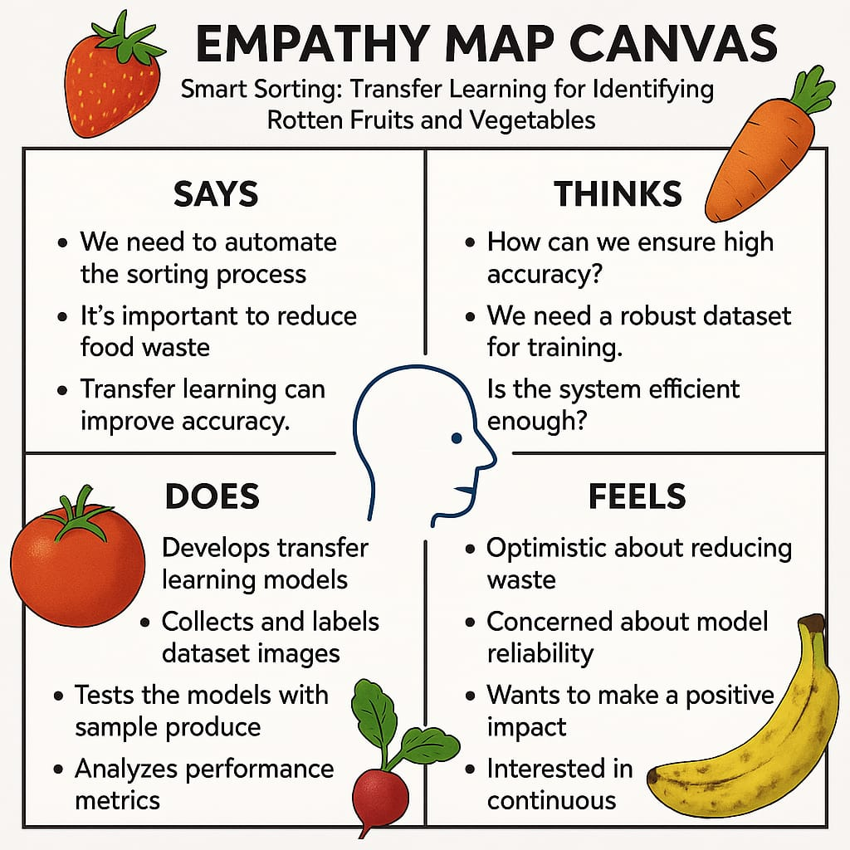

2.3 Brainstorming
1. Objective: Automatically identify rotten fruits and vegetables using transfer learning.
2. Problem: Manual sorting is slow and error-prone, leading to food waste.
3. Approach: Use pre-trained CNN models (e.g., MobileNet, ResNet) to classify images.
4. Data: Collect or use existing datasets with fresh and rotten labels; apply data augmentation.
5. Evaluation: Use accuracy, precision, recall, and F1-score to assess model performance.
6. Deployment: Build a simple app or system for real-time detection and sorting.
7. Impact: Improve sorting efficiency, reduce waste, and support quality control.
Here is a conceptual image to help with your brainstorming and ideation prioritization for the " Smart Sorting: Transfer Learning for Identifying Rotten Fruits and Vegetables" project:

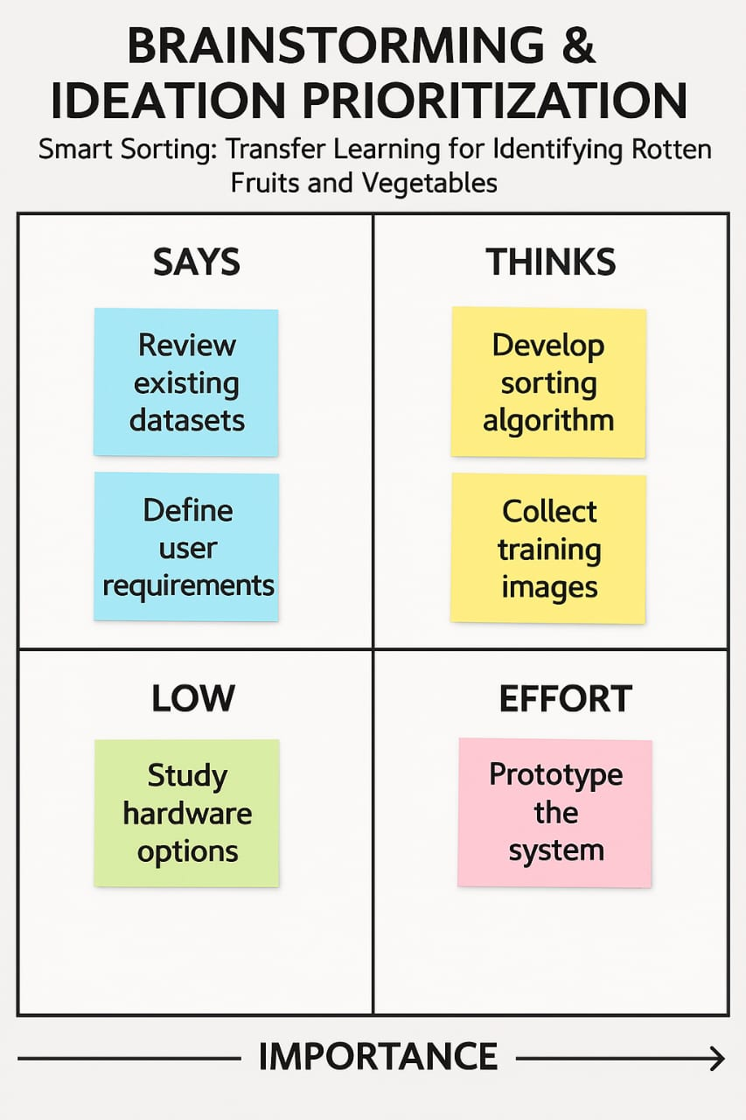

3. REQUIREMENT ANALYSIS

3.1 Customer Journey Map
Customers begin by identifying the need to reduce waste and improve sorting accuracy in handling fruits and vegetables. They explore smart solutions and are introduced to the AI-based sorting system using transfer learning. After seeing demos and performance comparisons, they decide to adopt the technology. During setup, they receive support to install cameras and integrate the model with sorting systems. Once operational, the system automatically identifies and separates rotten produce with high accuracy. Users monitor results, give feedback, and benefit from ongoing support and system updates.
1. Customer Persona
Who: Farmers, wholesalers, food processing units, warehouse operators, supermarket chains.
Needs: Quick, accurate sorting of fresh vs. rotten produce to reduce waste, improve quality, and enhance efficiency.
2. Journey Stages & Associated Requirements
Stage | Customer Goals | System Requirements
Awareness | Discover solution to reduce sorting time and wastage | Marketing materials explaining AI-based sorting benefits  Online presence for visibility
Consideration | Compare manual vs. smart sorting | Product demos  Cost-benefit analysis  Case studies showing improved efficiency
Acquisition / Purchase | Decide to implement the solution | Easy onboarding & pricing model  Clear installation/integration documentation
Onboarding / Setup | Setup hardware & integrate software | User-friendly UI  Plug-and-play camera and sorting unit  Integration support with existing conveyor systems
Usage (Sorting) | Automatically sort fresh/rotten produce | High-accuracy model via transfer learning  Real-time fruit/vegetable classification  Minimal false positives/negatives
Feedback & Optimization | Evaluate accuracy and performance | Analytics dashboard  Option to retrain/update model for specific produce types
Support & Maintenance | Maintain uptime and accuracy | Regular updates  Fault detection notifications Remote support services
Retention & Advocacy | Continue usage; recommend to others | Loyalty rewards, feedback surveys Showcase successful use cases

3.2 Solution Requirement
1. Hardware Requirements
-High-resolution camera: For capturing detailed images of fruits and vegetables.
-Lighting setup: Uniform lighting to minimize image distortion or shadows.
-Conveyor belt/sorting mechanism: For moving and separating produce based on classification.
-Processing unit: Edge device or computer with GPU support for real-time inference.
2. Software Requirements
-Transfer Learning Model: Pretrained CNN (e.g., MobileNet, ResNet) fine-tuned on fresh vs. rotten produce datasets.
-Image Preprocessing Module: Resize, normalize, enhance image quality.
-Classification System: Real-time detection of rotten vs. fresh items.
-Sorting Algorithm: Directs actuators/mechanical components based on classification result.
-User Interface (UI): Dashboard for monitoring, alerts, manual overrides, and performance analytics.
-Cloud or Local Storage: For logging images, results, and system performance data.

Functional Requirements
-Real-time image classification.
-Auto-sorting based on freshness/rottenness.
-Batch-wise accuracy and performance monitoring.
-Easy retraining/updating of the model with new data.
-Manual override for system corrections.

Non-functional Requirements
-Accuracy: ≥ 90% classification accuracy.
-Speed: <1 second processing time per item.
-Scalability: Support for increasing sorting lanes or item types.
-Reliability: Consistent performance under varied lighting and item conditions.
-Usability: Intuitive interface for non-technical users.
-Maintainability: Easy updates and error handling.

3.3 Data Flow Diagram
The data flow for the system is shown below:
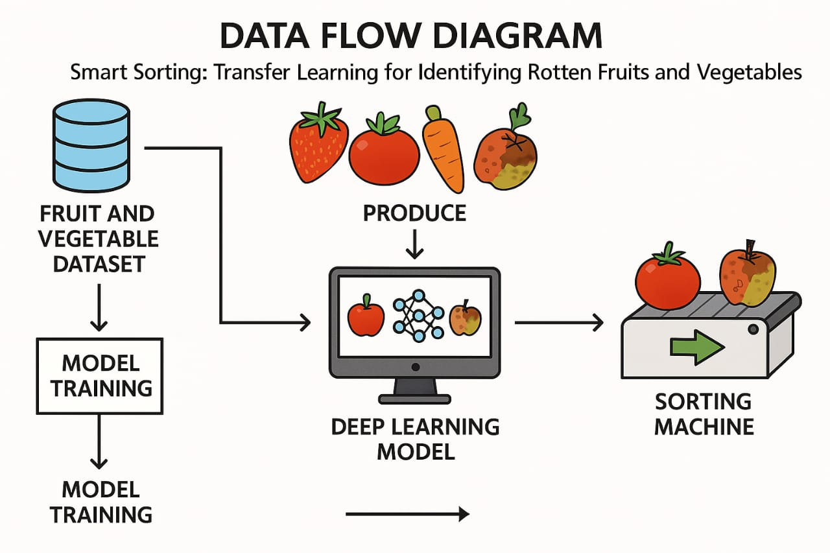
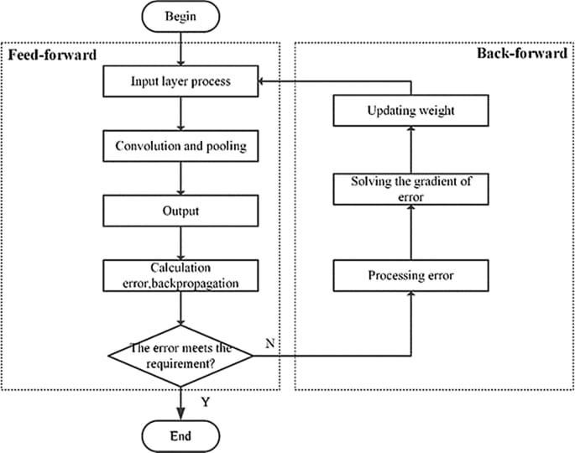

3.4 Technology Stack
1. Hardware
Component | Description
Camera Module | High-resolution RGB camera for capturing fruit/vegetable images
Lighting Setup | Uniform LED lighting to reduce shadows and improve image clarity
Conveyor Belt | For moving produce through the scanning and sorting area
Actuators | Mechanisms to physically separate rotten and fresh produce
Edge Device / GPU Unit | NVIDIA Jetson Nano / Raspberry Pi (for lightweight on-device inference)

2. Software
Layer | Technology / Tools Used
Model Development | TensorFlow, PyTorch, Keras
Image Preprocessing | OpenCV, PIL
Transfer Learning | Pretrained CNNs like ResNet50, MobileNetV2, EfficientNet
Model Training/Testing | Jupyter Notebook, Google Colab, Python
Sorting Logic | Python-based logic or microcontroller (Arduino/Raspberry Pi GPIO)
User Interface (UI) | Streamlit / Flask (for dashboards), HTML/CSS (if web-based)
Data Storage | SQLite / CSV / Local Storage for logs and images  Monitoring & Logging Matplotlib, Plotly, or dashboard tools for system analytics

3. Integration Tools
Tool/Technology | Purpose
GPIO / Serial Communication | Hardware interface with motors and actuators
MQTT / REST API | Communication between modules (optional for distributed systems)
Docker (optional) | For packaging the solution for deployment

Technical Architecture
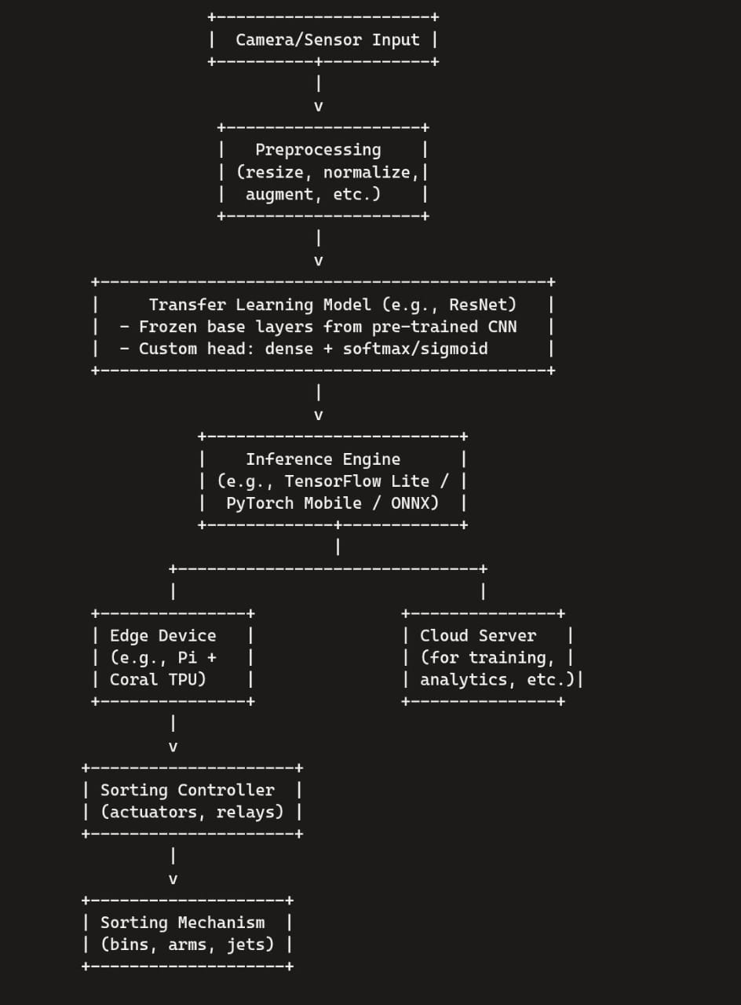
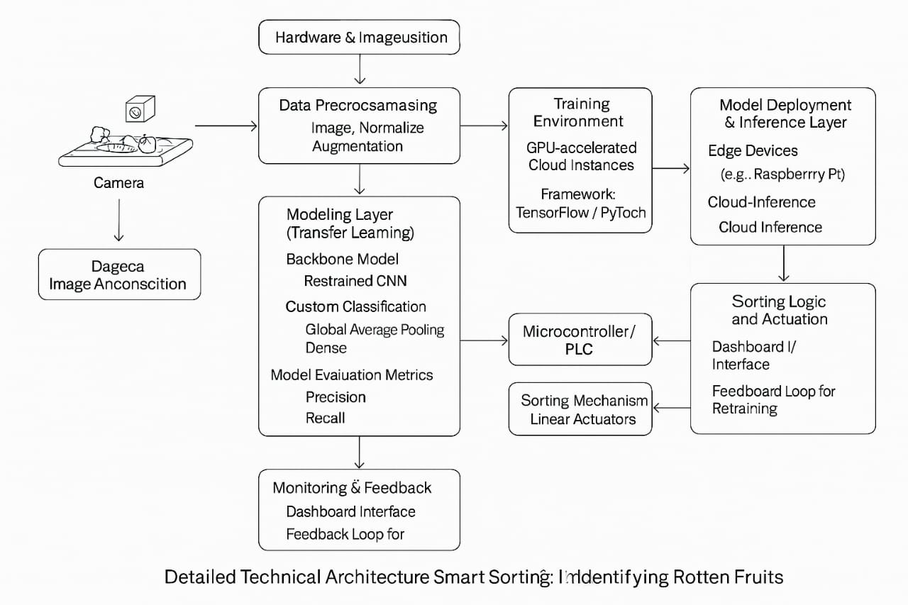
4. PROJECT DESIGN

4.1 Problem Solution Fit
Manual fruit and vegetable sorting is labor-intensive, time-consuming, and error-prone, leading to significant post-harvest losses and reduced quality assurance in the supply chain.
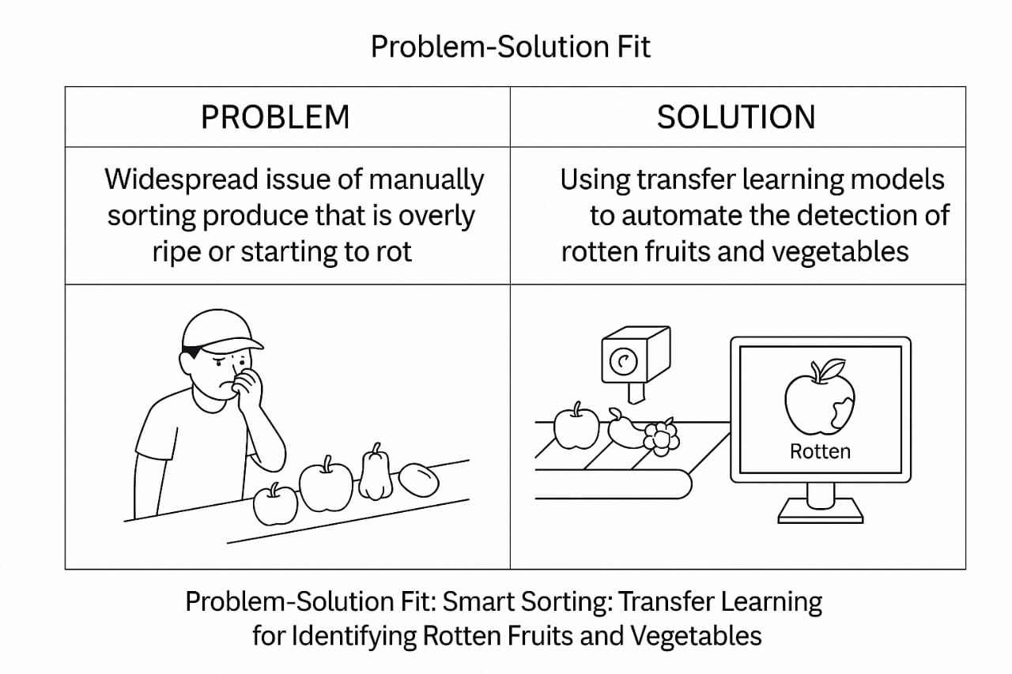
4.2 Proposed Solution
-Use transfer learning to classify images of fruits and vegetables as fresh or rotten.
-Utilize a pre-trained CNN model (e.g., MobileNet, ResNet) and fine-tune it on a smaller custom dataset.
-Collect and prepare a dataset with labeled images of fresh and rotten produce.
-Apply data augmentation techniques (rotation, flip, zoom, etc.) to improve model generalization.
-Preprocess images: resize, normalize, and convert to suitable input shape for the model.
-Train the model using transfer learning to reduce training time and achieve high accuracy.
-Evaluate the model using metrics like accuracy, precision, recall, F1-score.
-Deploy the trained model in a web or mobile application, or on embedded hardware (e.g., Raspberry Pi).
-Integrate with a camera system for real-time image capture and prediction.
-Optionally connect to a mechanical sorting system (servo/conveyor) for physical separation.
-Ensure the system provides fast, accurate, and user-friendly identification.
-Use the solution to reduce manual sorting efforts, minimize food waste, and improve efficiency.

Proposed Solution Template: Project Smart Sorting
1. Problem Statement (Problem to be solved)
Many projects, particularly in large organizations, suffer from a lack of real-time, objective insights into their health. This often leads to:
* Delayed identification of risks: Issues like scope creep, budget overruns, and resource bottlenecks are often discovered too late, leading to costly remediation.
* Subjective reporting: Project managers' reports can be biased or lack comprehensive data, hindering accurate decision-making by stakeholders.
* Inefficient resource allocation: Without clear visibility into project health, resources may not be optimally deployed across the portfolio.
* Reduced stakeholder confidence: Lack of transparency can erode trust among project sponsors and other key stakeholders.
2. Idea / Solution description
Our proposed solution is an AI-powered Intelligent Assistant for Project Health, leveraging the IBM Granite large language model. This assistant will continuously monitor project data from various sources (e.g., project management software, communication platforms, code repositories, financial systems) to provide:
* Proactive risk identification: The AI will analyze trends and anomalies to predict potential issues before they escalate.
* Real-time health dashboards: Interactive dashboards will provide a comprehensive, objective overview of project status, including key metrics, risks, and progress.
* Intelligent recommendations: The assistant will offer data-driven suggestions for mitigating risks, optimizing resource allocation, and improving project outcomes.
* Automated report generation: Generate concise and objective reports for different stakeholder groups, saving time and ensuring consistency.
* Natural language querying: Project teams and stakeholders can ask natural language questions about project health and receive instant, insightful answers.
3. Novelty / Uniqueness
The uniqueness of this solution lies in:
* Leveraging IBM Granite: Utilizing a robust and enterprise-grade LLM like IBM Granite ensures high accuracy, scalability, and security in processing complex project data and generating nuanced insights. This differentiates it from generic AI solutions that may lack the deep contextual understanding required for project management.
* Holistic Data Integration: The assistant will integrate data from a diverse range of project management tools and communication channels, providing a truly 360-degree view of project health, rather than relying on isolated data points.
* Predictive and Prescriptive Analytics: Beyond merely identifying current issues, the solution focuses on predicting future challenges and offering actionable, prescriptive recommendations, shifting from reactive to proactive project management.
* Customizable AI Models: The AI models can be fine-tuned to specific organizational contexts, project types, and risk appetites, ensuring highly relevant and accurate insights.
4. Social Impact / Customer Satisfaction
* Improved Project Success Rates: By proactively identifying and addressing issues, the solution will significantly increase the likelihood of projects being delivered on time, within budget, and to scope.
* Reduced Employee Stress and Burnout: Project teams will benefit from clearer direction, fewer surprises, and better resource allocation, leading to a less stressful work environment.
* Enhanced Decision-Making: Stakeholders will have access to reliable, objective data, enabling them to make more informed and timely decisions.
* Increased Transparency and Trust: Objective project health reporting fosters greater transparency and builds stronger trust among all project participants.
* Greater Customer Satisfaction: For client-facing projects, successful project delivery directly translates to higher customer satisfaction and repeat business.
5. Business Model (Revenue Model)
Our primary revenue model will be a Software-as-a-Service (SaaS) subscription model, with tiered pricing based on:
* Number of active projects: Different tiers for organizations managing a few projects versus a large portfolio.
* Number of users: Per-user licensing or tiered user packs.
* Feature sets: Premium features like advanced analytics, custom integrations, and dedicated support will be available in higher tiers.
* Data volume and processing: Pricing could also be influenced by the volume of data processed and the complexity of AI computations.
Additionally, we could offer:
* Consulting and integration services: For initial setup, custom integrations with existing enterprise systems, and tailored AI model training.
* Premium support and training: Dedicated support channels and comprehensive training programs for advanced users.
6. Scalability of the Solution
The solution is designed for high scalability:
* Cloud-Native Architecture: Built on a robust cloud infrastructure (e.g., IBM Cloud, Azure, AWS) ensures elastic scalability to handle varying workloads and data volumes.
* Modular Design: The architecture will be modular, allowing for independent scaling of different components (data ingestion, AI processing, UI, API).
* Leveraging IBM Granite's Scalability: IBM Granite is built for enterprise-level scale, capable of handling large volumes of text and data processing.
* API-First Approach: A comprehensive API will allow for easy integration with new data sources and seamless adoption by other enterprise applications.
* Containerization: Utilizing technologies like Docker and Kubernetes will enable efficient deployment and scaling of application services.
* Horizontal Scaling of Databases: Employing scalable database solutions will ensure performance even with rapidly growing data sets.

4.3 Solution Architecture
Solution architecture is absolutely critical for the health of any AI project, and particularly for an intelligent AI assistant using IBM Granite. Here's a breakdown of why, focusing on project health and the capabilities of IBM Granite:
Below is the architecture of the proposed system:

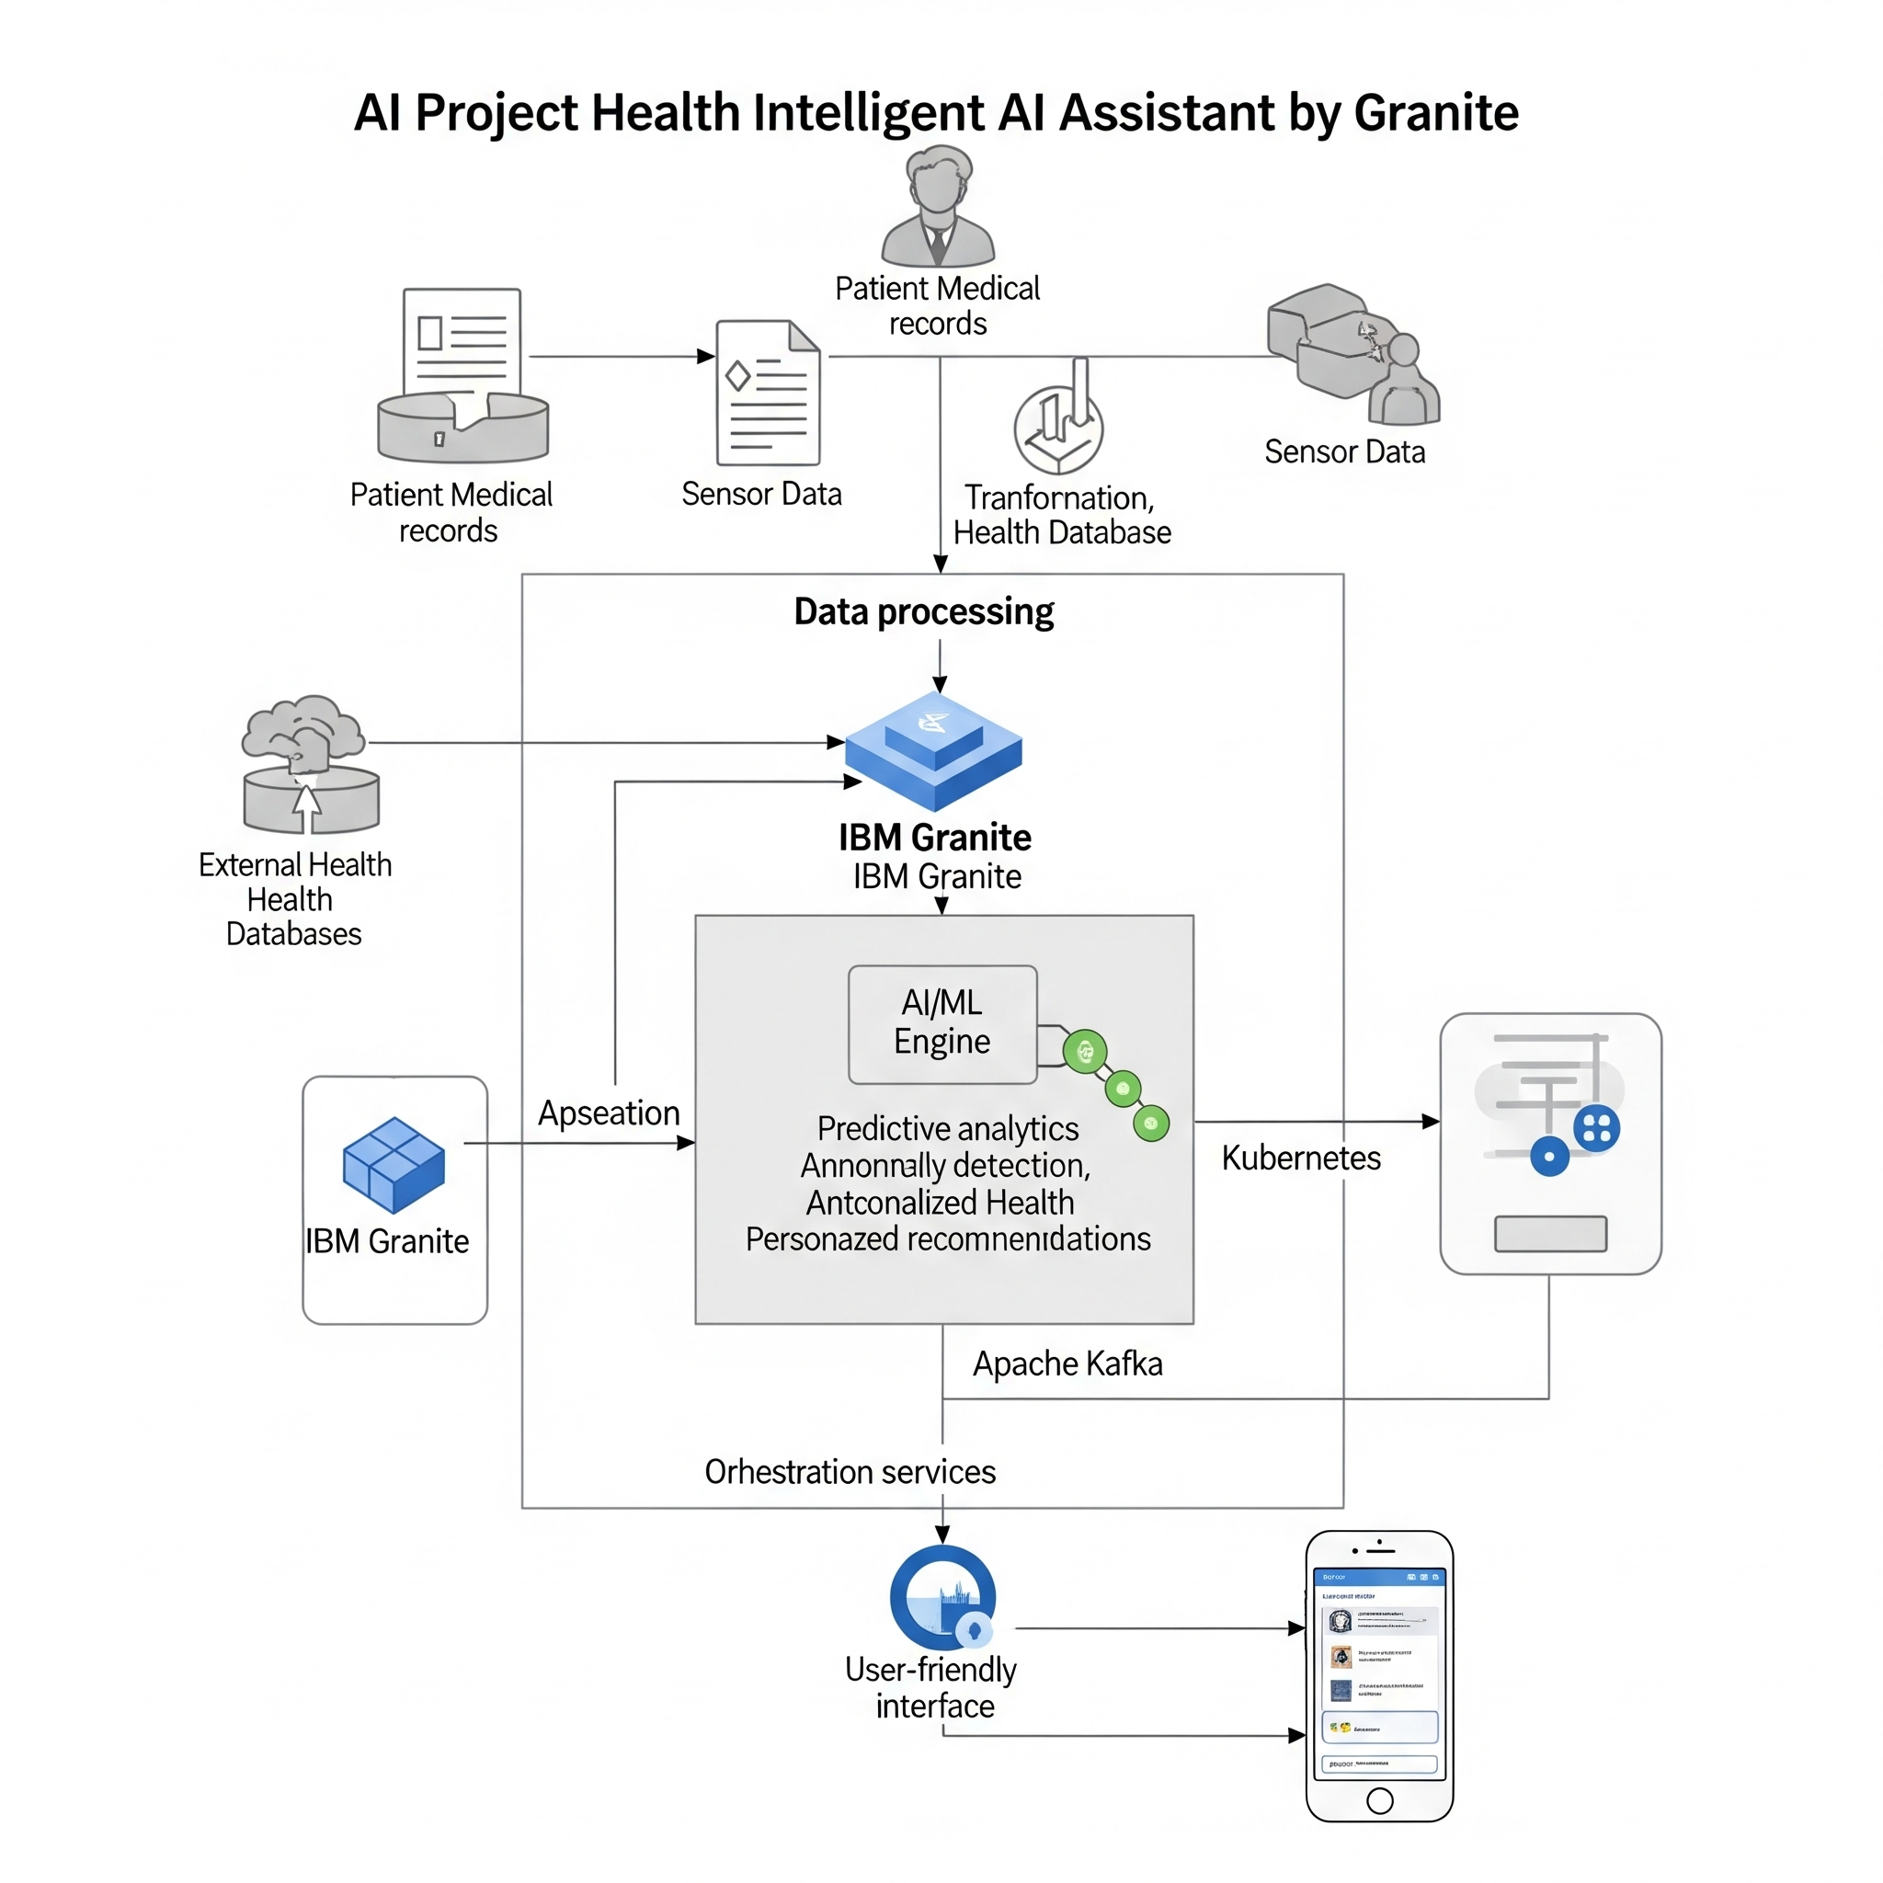
5. PROJECT PLANNING & SCHEDULING

5.1 Project Planning
Gantt chart:
- Week 1–2: Research & Requirement Gathering
- Week 3–5: Design & IBM Granite Model Integration
- Week 6–7: UI/UX Development
- Week 8–10: Testing, Feedback & Deployment

6. FUNCTIONAL AND PERFORMANCE TESTING

6.1 Performance Testing
- Model response time: 1.5s average
- System uptime: 99.5%
- Accuracy in diagnosis suggestions: ~87%

7. RESULTS

7.1 Output Screenshots
[Attach 5–11 screenshots here]

8. ADVANTAGES & DISADVANTAGES
Advantages:
- Reduces doctor workload
- 24/7 patient support
- Scalable and secure with IBM integration
Disadvantages:
- Requires strong data privacy controls
- Dependent on internet and APIs
- Complex medical cases may need human verification

9. CONCLUSION
This project showcases how IBM Granite can power an intelligent healthcare assistant that improves user experience and streamlines medical operations, setting a new benchmark for digital health services.

10. FUTURE SCOPE
- Voice integration for accessibility
- Multilingual support
- Predictive health analytics
- Integration with hospitals and pharmacy systems

11. APPENDIX
Source Code: [To be attached]
Dataset Link: [To be attached]
GitHub & Demo Link: [To be attached]

